***Web Technologies***

***Assignment 6***

***Web Analytics***

**Name: Rahul Challa**

**CWID: 20079716**

**MSIS517L**

**Professor: Michael Gildein**

**🡪 Google Analytics Dashboard screenshots:**

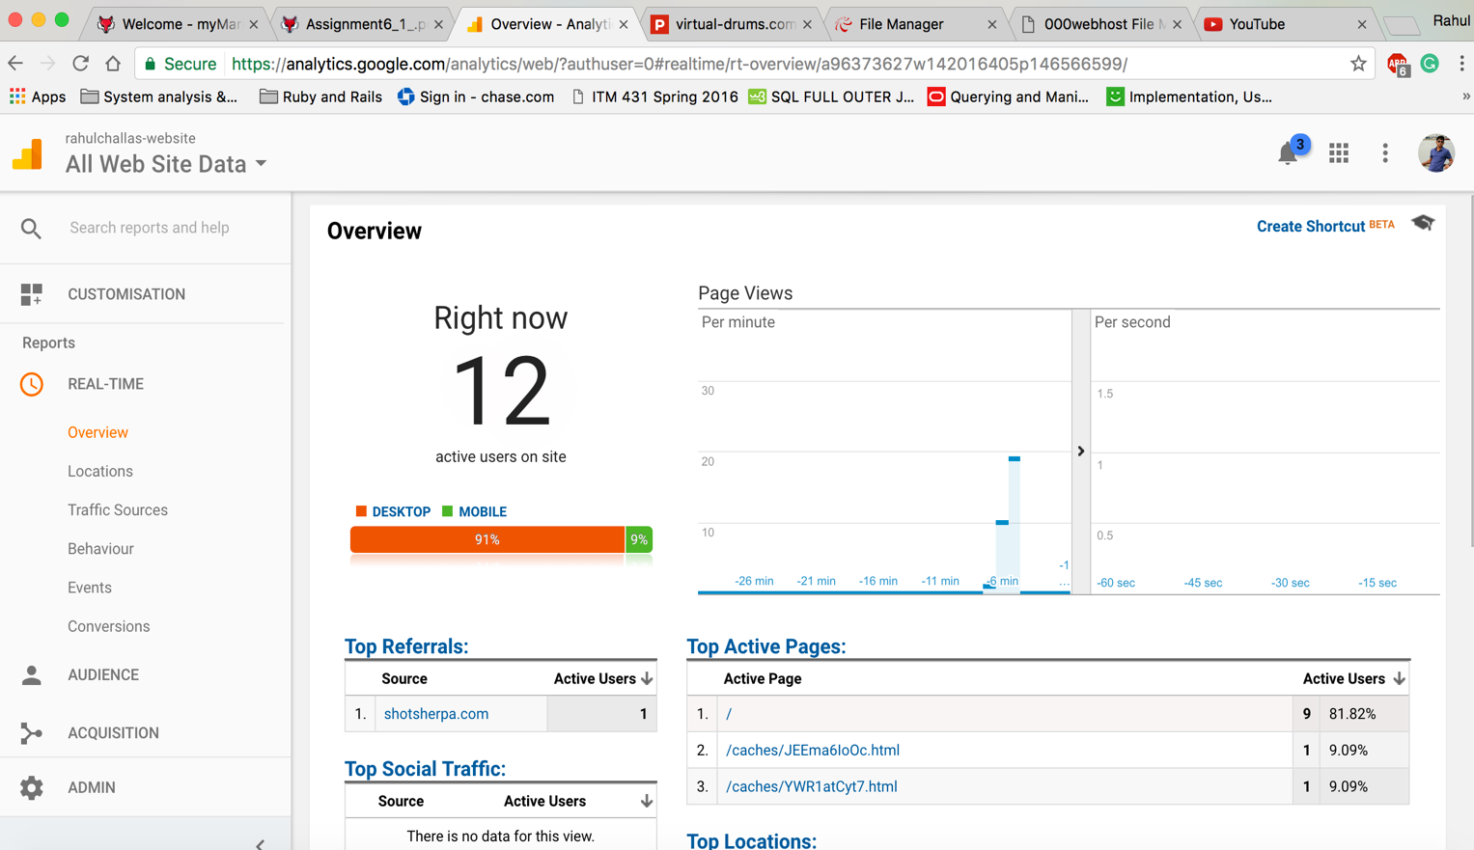

**Figure 1**

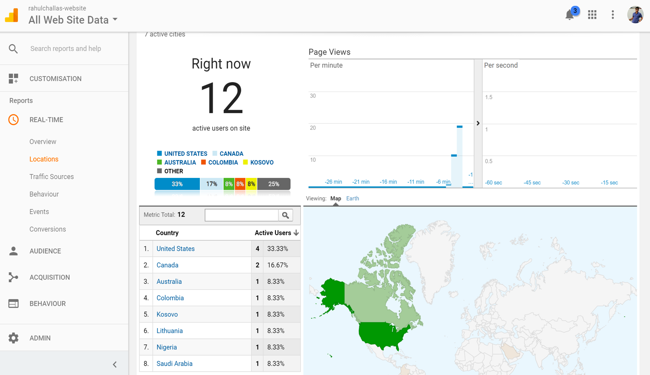

**Figure 2**

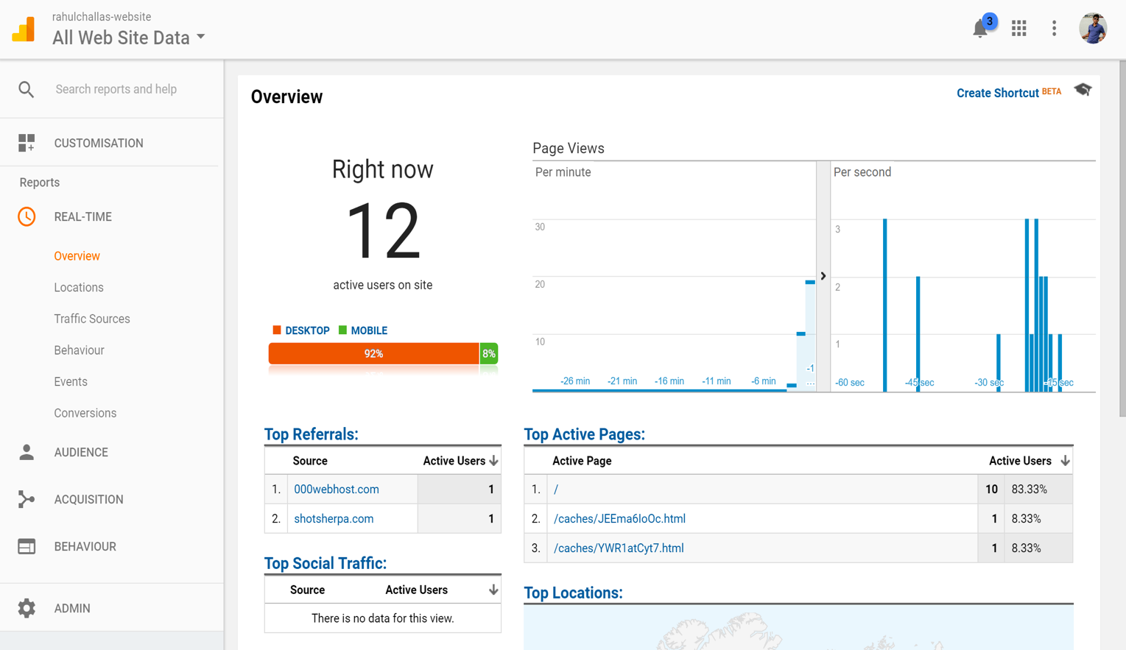

**Figure 3**

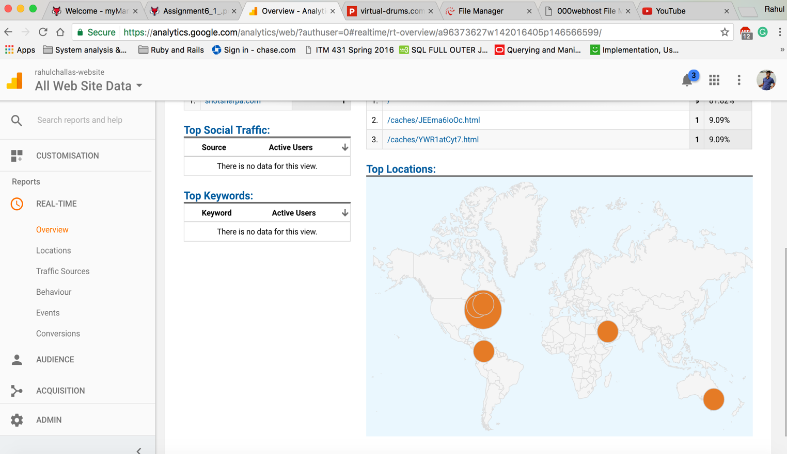

**Figure 4**